Policy Name | Travel Grant Policy
Proposed By | Director ORIC
Reviewed By | Registrar and Pro-VC
Approved By | ORIC Steering Committee
Effective From | 01-07-2026
Next Review Date | 30-06-2028
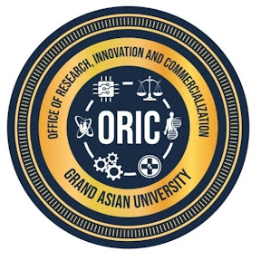
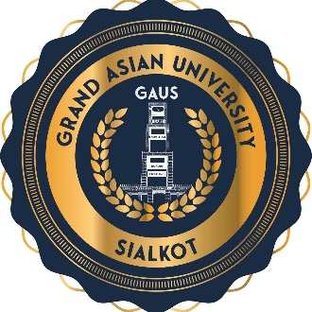
- Purpose
The University recognizes that participation in national and international conferences enhances research quality, promotes international collaboration, increases the visibility of the University's research, and contributes to the professional development of faculty members and researchers. This policy establishes a transparent framework for providing financial assistance to faculty members and researchers for presenting their scholarly work at reputable conferences, symposiums, workshops, and academic meetings.
- Objectives
The policy aims to:
- Enhance the University's national and international research visibility.
- Encourage publication in quality conferences and indexed proceedings.
- Foster national and international research collaborations.
- Support professional development of faculty and researchers.
- Improve institutional rankings and research reputation.

- Scope
This policy applies to all research conducted under the auspices or affiliation of Islam Group and Grand Asian University, regardless of discipline, funding source, or location. It applies to faculty members, researchers, visiting scholars, research associates, consultants, administrative staff involved in research administration, and external collaborators undertaking research on behalf of the University.
- Eligibility
- Full-time employee or registered researcher of the University after completing one year at GAUS can apply for the travel grant.
- The research paper to be presented by the applicant must be accepted for oral presentation in a conference/ seminar/ symposium etc.
- The applicant will have to provide a copy of the full research paper to be presented and its similarity report. The Similarity Index should be less than 19%.
- The applicant will have to present a valid acceptance letter for oral presentation mentioning the complete address, phone and fax number and the email address of the event organizers.

- Policy Rules
- For the international travel grant, the researcher must apply to HEC first and then GAUS afterward.
- For the travel grant researcher shall apply at least 08 weeks (60 days) before the conference date.
- In case of funding from HEC/PHEC etc., researchers will have to manage within the funding limits of funding agencies.
- In case of more than one applicant from the same department, preference will be given to faculty members who haven’t availed travel grant during the last two years. In case of tie, the decision will be made by the committee.
- Preference shall be given to conferences indexed in Scopus, Web of Science, IEEE, ACM, or other internationally recognized indexing services.
- In case of funding from HEC/PHEC etc., the advance may be given to the researcher as a loan. It will be adjusted as per GAUS policy after the conference.
- Travel grant for one local or international conference will be permissible to any researcher in a year as per rules and approval of the competent authority.
- The registration fee for local conference must not exceed Rs 5000. TA/DA/ boarding lodging shall be provided as per HR policy.
- For international conferences, a registration fee of up to $ 500 is permissible. Economy class travel is permitted, and faculty members are required to submit three quotes with preference given to the lowest quotation.
- Faculty can claim reimbursements for local conferences after attending conference, however prior approval is must.
- Support shall not be provided at conferences organized by fake and business-oriented private organizations.
- GAUS will cover the 90% of approved registration and travel expenses for International Conferences (outside Pakistan) and 10% will be borne by applicant.
- An applicant has won a grant from GAUS, he/she must publish at least one HEC recognized journal paper before applying for the next grant.
- If a faculty member/researcher leaves GAUS within one year of utilizing an International Travel Grant, they must reimburse 50% of the total grant received.

- Eligible Conferences
Financial support shall be available only for conferences organized by:
- Recognized universities
- Professional societies
- Government organizations
- International research associations
- Reputable academic publishers
- International scientific organizations

- Application Procedure
Applicants shall submit the following to ORIC at least 60 days before departure:
- Travel Grant Application Form
- Conference acceptance letter
- Copy of abstract or paper
- Conference brochure or website details
- Estimated budget
- Endorsement by Head of Department and Dean
- Evidence of conference indexing (if applicable)
- Obligations of Grant Recipients
Within 15 days of returning, recipients shall submit:
- Conference participation report
- Boarding passes and travel documents
- Original invoices and receipts
- Presentation certificate
- Conference participation certificate
- Evidence of networking or collaboration opportunities
- Future action plan arising from the conference
- Ineligible Expenses
The University shall not reimburse:
- Personal sightseeing or tourism
- Family or companion expenses
- Upgraded airfare or luxury accommodation
- Alcoholic beverages
- Personal shopping
- Fines or penalties
- Expenses not supported by original receipts
- Policy Review and Amendments
This policy should be reviewed every two years, or earlier if required, to ensure alignment with the University's strategic priorities, HEC regulations, emerging technologies, and best international practices. Amendments shall be approved by the appropriate statutory bodies of the University.
Proposed By: Approved By:

Director ORIC Vice Chancellor/ Chairman ORIC-SC
Grand Asian University Sialkot Grand Asian University Sialkot

